**PROJECT DOCUMENTATION**

Rhythmic Tunes: Your melodic companion

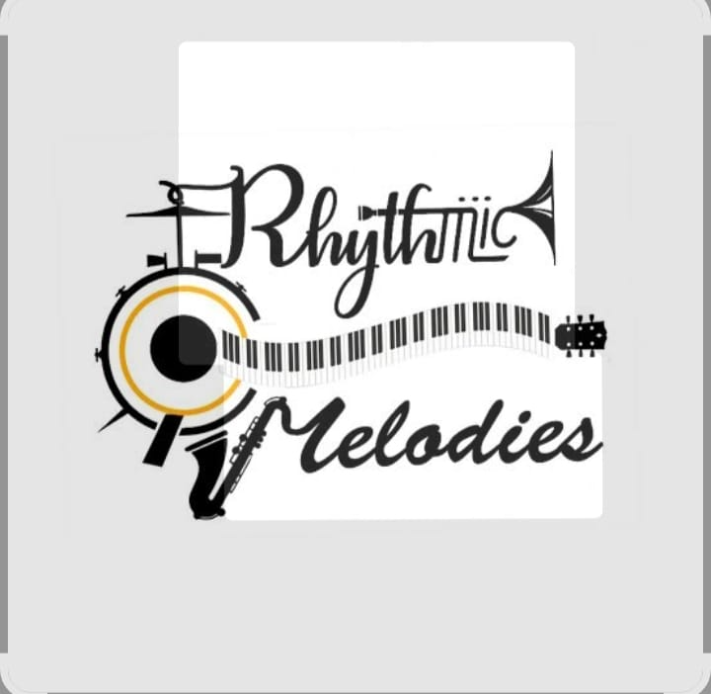

**Project Title:** Rhythmic Tunes: Your melodic companion

**Team ID: NM2025TMID36545**

**Team Leader:**

* **DEVADHARSHINI.S- 24csdevadharshini019@gmail.com**

**Team Members:**

* [**DEEPIKA.S - 24csdeepika018@gmail.com**](mailto:DEEPIKA.S%20-%2024csdeepika018@gmail.com)
* [**DEVITHARSHINI.P- 24csdevitharshini020@gmail.com**](mailto:DEVITHARSHINI.P-%2024csdevitharshini020@gmail.com)
* [**DHANALAKSHMI.A-24csdhanalakshmi021@gmail.com**](mailto:DHANALAKSHMI.A-24csdhanalakshmi021@gmail.com)

**Project Overview**

**Purpose:**

**The purpose of the Rhythmic Tunes project is to design and develop a user-friendly platform that allows music lovers to explore, play, and enjoy rhythmic melodies seamlessly. The project aims to provide an engaging digital music experience with intuitive navigation, customizable features, and a visually appealing interface. By combining creativity with technology, Rhythmic Tunes seeks to deliver an enjoyable and interactive way to connect listeners with music.**

**Features of Rhythmic Tunes 🎶:**

**1. Music Library – Organize songs by albums, artists, playlists, and genres.**

**2. Playlists Creation – Let users create, edit, and share playlists.**

**3. Smart Recommendations – Suggest songs based on listening history and mood.**

**4. Search Functionality – Quickly find songs, albums, or artists.**

**5. Offline Mode – Download and listen to songs without internet.**

**6. Lyrics Display – Show synced lyrics while a song plays.**

**🎧 Playback Features**

**7. High-Quality Streaming – Multiple sound quality options (normal, high, lossless**

**8. Equalizer Settings – Adjust bass, treble, and sound effects.**

**9. Crossfade & Gapless Playback – Smooth transitions between songs.**

**10. Queue Management – Add, remove, or rearrange upcoming songs.**

**11. Repeat & Shuffle Modes – Flexible playback control.**

**🧑‍🤝‍🧑 Social & Interactive Features**

**12. Friend Activity Feed – See what friends are listening to.**

**13. Collaborative Playlists – Create playlists with friends.**

**14. Song Sharing – Share directly to social media or chat apps.**

**15. User Profiles – Show favorite artists, playlists, and listening habits.**

**🌐 Smart Companion Feature**

**16. Mood-Based Playlists – Auto-generate playlists (happy, workout, study, relax).**

**17. AI-Powered DJ – Personalized mixes like a virtual DJ.**

**18. Voice Commands – Control music hands-free.**

**19. Daily/Weekly Mixes – Personalized discovery playlists.**

**20. Podcast & Radio Support – Stream podcasts and online radio stations.**

**📱 Device & Experience Features**

**21. Cross-Device Sync – Continue listening seamlessly across devices.**

**22. Smart Wearable Support – Integration with smartwatches and fitness apps.**

**23. Car Mode – Simplified UI for safe driving.**

**24. Background Playback – Music continues while using other apps.**

**25. Sleep Timer – Auto-stop music at bedtime.**

**FRONTED:**

**Drums are a fascinating instrument with a rich history and versatility. Here are some more details:**

**Types of Drums**

**1. *Acoustic Drums*: Traditional drums that produce sound when hit with sticks or hands.**

**2. *Electronic Drums*: Digital drums that produce sound electronically, often used in recording studios or live performances.**

**Drumming Techniques**

**1. *Rudiments*: Basic drumming patterns, such as single strokes, double strokes, and paradiddles.**

**2. *Groove Playing*: Playing along with a rhythm or beat, often in a band or ensemble setting.**

**Drums in Different Genres**

**1. *Rock Music*: Drums are a key element in rock music, providing driving rhythms and powerful beats2. *Jazz Music*: Drums are used in jazz to create complex rhythms and improvisational patterns.**

**3. *World Music*: Drums are used in various traditional music styles around the world, such as African, Latin American, and Asian music.**

**Benefits of Drumming**

**1. *Physical Exercise*: Drumming can improve hand-eye coordination, fine motor skills, and cardiovascular health.**

**2. *Stress Relief*: Drumming can be a therapeutic outlet for stress and anxiety.**

**3. *Creativity*: Drumming allows for creative expression and improvisation.**

**Would you like to know more about drumming or is there something specific you'd like to explore further?interaction.**

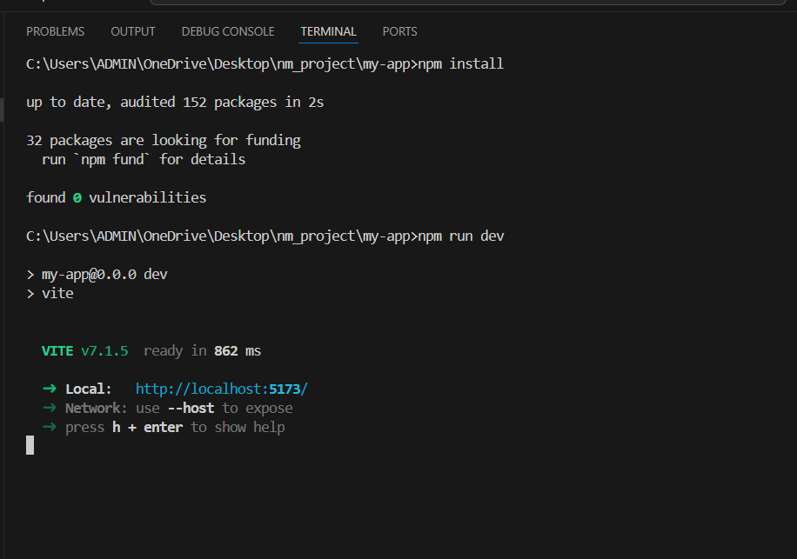

**Prerequisites:**

**Fundamental Elements of Rhythm**

**Before you can appreciate or create a rhythmic tune, you need to understand the basic building blocks of rhythm itself.**

**Beat: This is the basic, steady pulse of the music. It's what you tap your foot or clap your hands to. The beat can be definite, like a drum, or indefinite, like a pulse that is simply felt.**

**Tempo: The speed of the beat, measured in beats per minute (BPM). Tempo can be slow (e.g., largo, adagio), moderate (andante, moderato), or fast (allegro, presto).**

**Meter: The organization of beats into regular groups, or measures. The meter is indicated by the time signature (e.g., 4/4, 3/4, 6/8). The top number tells you how many beats are in each measure, and the bottom number tells you which type of note gets one beat.**

**Downbeat: The first, and usually strongest, beat of a measure.**

**Upbeat: The last beat of a measure, leading into the next downbeat.**

**Note Duration: The length of time a note is played. Different types of notes (e.g., whole notes, half notes, quarter notes, eighth notes) have different durations relative to one another.**

**Accent: The emphasis placed on a particular note or beat, making it louder or stronger. This creates dynamic contrast and character within a rhythm.**

**2. Developing a Sense of Rhythm**

**A deep understanding of rhythmic tunes goes beyond just knowing the theory. It requires a developed "sense" of rhythm.**

**Internal Metronome: The ability to feel and maintain a steady beat internally without an external guide. This is often practiced using a metronome.**

**"Feeling" the Pulse: Being able to instinctively feel the beat and phrases of a song, even during complex parts. This is why practices like dancing or clapping along to music are so effective.**

**Listening and Imitation: Paying close attention to the rhythms in different genres of music. This helps to train your ear to recognize patterns and accents.**

**Rhythmic Exercises: Actively practicing rhythmic patterns, for example, by clapping, singing, or playing them on an instrument. This can be as simple as counting out loud or using syllables like "ta" and "ti-ti" to represent note values.**

**3. Key Concepts for Rhythmic Complexity**

**Rhythmic tunes are often characterized by more than just a simple, steady beat. They may incorporate advanced techniques to create interest and a unique "groove."**

**Syncopation: Placing the emphasis on a weak beat or a part of the beat that is not typically accented. This creates a sense of surprise, tension, and a "swing" feel often found in jazz, funk, and Latin music.**

**Polyrhythms: The simultaneous use of two or more independent rhythmic patterns. For example, a drummer might play a 4/4 rhythm while a percussionist plays a 3/4 rhythm on top of it. This creates a dense, layered effect.**

**Ostinato: A rhythmic pattern that is repeated over and over again throughout a piece of music. This can provide a hypnotic effect and a foundational layer for other musical elements.**

**Rubato: A flexible and expressive manipulation of tempo by a performer. It's a "stolen time" where time is taken from some measures and given to others, adding a fluid, human feel to the music.**

**By understanding these elements and actively practicing them, a musician or listener can go beyond simply hearing a tune and begin to truly feel and appreciate its rhythmic structure and character.**

**Installation Steps:**

**1. Install Visual Studio Code and open it on your system.**

**2. Download and install Node.js (latest stable version).**

**3. Install MongoDB and set up the local database service.**

**4. Clone the project repository using Git:**

**git clone <repository_link>**

**5. Open the project in VS Code and verify that dependencies are properly installed.**

Folder Structure

Key Organizational Principles

Consistency is Crucial: Whatever system you choose, stick to it. This prevents confusion and makes it easy to find files quickly.

Leverage Metadata: While folder structure is important, remember that most modern music players rely on metadata (the embedded information in a song file, like artist, album, and genre). The best system uses both.

Start Broad, Go Specific: Begin with the broadest categories and drill down to the most specific. This mimics how you might search for music in your head.

Common Folder Structures

Here are a few popular and effective models for organizing a rhythmic tune library.

1. By Artist and Album

This is the most traditional and widely used method. It is best for a collection of full albums or artist discographies.

Music/

Artist Name A/

Album Title 1/

01 - Track Title.mp3

02 - Another Track.mp3

Album Title 2/

Artist Name B/

Singles/

Track Title.mp3

2. By Genre and Subgenre

This is particularly useful for DJs or producers who need to quickly find a song with a specific "vibe."

Music/

Genre Name A/

Subgenre 1/

Artist Name - Track Title.mp3

Subgenre 2/

Genre Name B/

This structure works well for rhythmic music like house, techno, or drum & bass, where the genre itself is the primary organizing factor.

3. By Vibe or Mood

Many people find it more intuitive to organize by the feeling of the music rather than a strict genre. This method is great for creating playlists on the fly or for soundtracks for different activities.

Music/

High Energy/

Driving Rhythm/

Artist Name - Track Title.mp3

Upbeat Party/

Chill/

Ambient Grooves/

Lofi Beats/

This can be combined with other structures, for example, by having a Vibes folder with subfolders for different moods, and within those, you can use one of the other structures.

Best Practices for File Naming

Beyond the folder structure, a consistent file-naming convention will save you a lot of headaches.

Include Key Details: A good naming convention for a track is often [Track Number] - [Artist Name] - [Track Title].[File Extension].

Use Consistent Tags: Use software like iTunes or a dedicated tag editor (e.g., MP3tag) to ensure that the metadata is accurate and consistent across your entire library. This is especially important for things like tempo (BPM) and key, which can be critical for rhythmic genres.

Organizing your music library to finish songs fast. This video provides a good overview of how to organize a sample library, a key component of creating rhythmic tunes.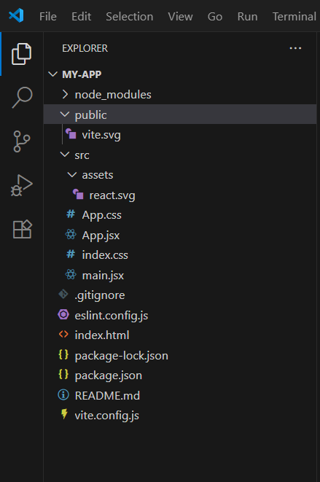

Running the Application

For Learning and Practice

If your goal is to improve your personal rhythm skills, you'll be "running" a rhythm training app. These applications are designed as digital tutors and use exercises and games to help you internalize a steady beat.

How to "Run" them:

Download/Access the App: Find a rhythm training app on your smartphone, tablet, or web browser (e.g., Perfect Ear, Complete Rhythm Trainer, or Chrome Music Lab's Rhythm experiment).

Start an Exercise: The app will present a rhythmic pattern in a few different ways:

Visual: You'll see a notation of the rhythm (e.g., quarter notes, eighth notes, rests).

Auditory: You'll hear the rhythm played on a metronome or a simple drum sound.

Interact with the Application: Your task is to replicate the rhythm by:

Tapping: Tapping a button or the screen in time with the beat.

Clapping: Clapping along with the rhythm.

Singing: Singing the pattern.

Receive Feedback: The app will analyze your timing and provide instant feedback, often showing you how early or late you were on each note. This is the key to improving.

Progress Through Levels: Most apps are structured in a "gamified" way, with chapters or levels that increase in difficulty, introducing more complex concepts like syncopation and polyrhythms.

2. For Creation and Composition

If you want to create your own rhythmic tunes, you will use a Digital Audio Workstation (DAW) or a beat-making application. This is a much more involved process.

How to "Run" a DAW for Rhythmic Composition:

Launch the Software: Open your chosen DAW (e.g., Ableton Live, FL Studio, Logic Pro, GarageBand).

Set Up a Project:

Tempo (BPM): The first step is to set the tempo, or BPM (beats per minute). This is the speed of your song.

Time Signature: Set the time signature (e.g., 4/4, 3/4) to define the meter of your song.

Add a Rhythm Track:

Use a Drum Machine: Drag and drop a virtual drum machine instrument into your project. This is a common way to build beats.

Load a Drum Kit: Select a "kit" of drum sounds (kick, snare, hi-hat, etc.) that fits the genre of your tune.

Use a Sequencer: Most DAWs have a built-in step sequencer (a grid of 16, 32, or more steps). You "run" it by clicking on the grid to place drum sounds on different beats, creating a rhythmic pattern.

Compose the Pattern:

Kick Drum: Place the kick on the strong beats (e.g., 1 and 3 in a 4/4 meter).

Snare Drum: Place the snare on the off-beats (e.g., 2 and 4).

Hi-Hat: Add hi-hats, often on every eighth or sixteenth note, to add a sense of movement and "groove."

Add Syncopation: To make it a more "rhythmic tune," you would then experiment with syncopation by placing notes on the weak parts of the beat (e.g., the "and" of beat 2).

Arrange the Song: Once you have a basic rhythmic pattern, you can "run" the arrangement by copying and pasting the pattern into a longer timeline. You would then add variations, breaks, and fills to create a full song structure (e.g., Verse, Chorus, Bridge).

Add Melodic Elements: After the rhythm is established, you can add other instruments like basslines, synthesizers, or a melody. These will be played "in time" with the rhythm you've already created.

Export the Final Track: Once your tune is complete, you "run" the final step by exporting the project as an audio file (like an MP3 or WAV).

3. For Simple Playback and Listening

If you simply want to listen to and experience rhythmic tunes, you "run" a music player application. This is the simplest form of interaction.

How to "Run" a Music Player:

Open the App: Launch a music player (e.g., Spotify, Apple Music, VLC).

Browse and Select: Navigate through your library or a streaming service's catalog, perhaps using the "rhythmic" or "percussive" tags.

Press Play: Select a track and press the play button.

In this context, "running" the application is just about initiating playback and experiencing the rhythm as a listener, which is a crucial part of appreciating the music

.API Documentation

Music Analysis APIs

These APIs are designed to analyze an audio file (a song) and extract its musical attributes, including rhythmic data. They are commonly used by music streaming services, music recommendation engines, and DJs.

Key Endpoints and Parameters:

GET /analyze or POST /audio:

Input: An audio file (MP3, WAV, etc.) or a track ID from a streaming service (like Spotify).

Output: A JSON object containing various musical features.

Rhythmic Features in the Output:

tempo (BPM): The estimated speed of the track in beats per minute. This is a fundamental rhythmic metric.

time_signature: The estimated meter of the song (e.g., 4/4, 3/4).

danceability: A value from 0.0 to 1.0 that describes how suitable a track is for dancing. This is a complex metric that considers a combination of tempo, rhythm stability, and beat strength.

energy: A measure of intensity and activity. Highly rhythmic, fast, and loud tracks (like dance music) will have high energy scores. This is often correlated with rhythmic elements like "onset rate" (how frequently notes begin).

liveness: A value from 0.0 to 1.0 that detects the presence of an audience, which can be an indicator of rhythmic fluctuations typical of a live performance.

rhythm_patterns / rhythm_histograms: Some advanced APIs provide a more granular breakdown of the rhythmic patterns within the song, often as a data array or a histogram.

Examples of APIs with these features:

Spotify's Web API (specifically the GET /v1/audio-features/{id} endpoint)

Soundcharts API

Cyanite.ai

2. Music Generation and Creation APIs

These APIs are for developers who want to programmatically create or manipulate music, often with a focus on rhythm. They are used in AI music generators, game development (for dynamic soundtracks), and interactive art projects.

Key Endpoints and Parameters:

POST /generate:

Input: Text prompts (e.g., "upbeat jazz beat," "melancholic, syncopated rhythm"), or a set of parameters.

Parameters often include:

tempo (BPM)

time_signature

rhythm_density: A value or an array that controls the number of rhythmic events in a measure.

syncopation_level: A parameter to control how much the generated rhythm deviates from a simple, on-the-beat pattern.

instrumentation: The types of drums or percussion to use.

Output: An audio file or a MIDI file of the generated track.

POST /create_rhythm:

Input: A simplified representation of a rhythm, like a binary array ([1, 0, 1, 0]) where 1 is a note and 0 is a rest.

Output: A sound file or MIDI data of that specific pattern played with a chosen instrument.

Examples of APIs with these features:

DiffRhythm (an AI-powered text-to-music API)

Mubert API (generates music from user specifications)

APIs used by platforms like Chrome Music Lab (which often use open-source libraries like Web Audio API and Tone.js).

3. Rhythm Training and Education APIs

These APIs are less common but would be used to build rhythm-based games or educational apps.

Key Endpoints and Parameters:

GET /generate_rhythm_pattern:

Parameters: difficulty_level, genre, meter.

Output: A rhythmic pattern in a structured format (e.g., JSON array of note durations and rests).

POST /analyze_user_rhythm:

Input: User's audio or a sequence of taps.

Output: A score and detailed feedback on the user's timing, showing which notes were played early or late.

In summary, when looking for "API documentation for rhythmic tunes," you should search for documentation for music analysis APIs, AI music generation APIs, or audio-specific libraries that have functions for beat detection, tempo analysis, or rhythmic pattern generation.Authentication

Authentication in Rhythmic Tunes ensures that only authorized users can access private resources and perform secure operations. The system uses JWT (JSON Web Token)-based authentication, which is a widely adopted mechanism for modern web applications.

JWT-based Authentication:

– When a user logs in, the server generates a JWT token that contains encrypted user details.

– This token is returned to the client and stored securely (usually in local storage or cookies).

– For each subsequent request to private APIs, the client must include this token in the request header.

– The server verifies the token before granting access to the requested resource.

Middleware Protection:

– Middleware functions are implemented in the backend to validate tokens automatically.

– Any request without a valid JWT is rejected with an appropriate error code (401 Unauthorized).

– This ensures sensitive operations such as creating playlists, sending chats, or managing user profiles are secured.

Password Security:

– User passwords are hashed before being stored in the database using modern encryption algorithms (e.g., bcrypt).

– Plain-text passwords are never stored, ensuring maximum safety even if the database is compromised.

Access Control:

– Different roles (e.g., User, Admin) have specific permissions.

– Admins can manage overall system activities, while users are restricted to their own accounts and playlists.

User Interface

The User Interface (UI) of Rhythmic Tunes is designed to provide a seamless, engaging, and intuitive experience for all users. The system uses React.js with Material UI and Bootstrap to deliver a modern, responsive design that adapts to multiple devices.

Landing Page:

– The first page users encounter, showcasing the project’s purpose and features.

– Includes a navigation menu, login/register buttons, and a quick overview of services.

– Designed to attract users with visually appealing elements such as banners and animations.

Freelancer Dashboard (User Dashboard in this case):

– Personalized dashboard for users to manage their playlists, discover music, and track activity.

– Displays recommended songs, trending playlists, and recently played tracks.

– Provides quick access to actions like creating a new playlist or editing existing ones.

Admin Panel:

– Accessible only by system administrators.

– Used for monitoring overall platform activity, managing users, handling reported content, and updating music collections.

– Ensures smooth functioning of the system with role-based access.

Project Details Page (Playlist Details Page):

– Provides detailed information about a selected playlist or music collection.

– Includes options such as play, add to favorites, provide feedback, and share.

– Displays user reviews, ratings, and related recommendations.

UI Characteristics:

Responsive Design: Works smoothly on desktops, tablets, and mobile devices.

Interactive Elements: Includes dynamic music players, search bars, and filtering options.

User-Friendly Layout: Minimal clicks required to access key features, reducing complexity.

Accessibility: Designed with color contrasts and clear navigation to support diverse user needs.

Testing 🎧

1. Testing Approach

Adopt manual testing for initial phases, then gradually move toward automated testing for critical modules.

Testing will focus on functionality, usability, performance, and compatibility across devices.

2. Types of Testing

1. Unit Testing

Test individual components such as play, pause, next, previous, and volume controls.

Verify database queries (fetching songs, saving playlists).

2. Integration Testing

Ensure seamless connection between frontend ↔ backend ↔ database.

Example: When a user clicks “Play,” the backend should fetch the correct file and the frontend should play it.

3. Functional Testing

Validate that all features (search, favorites, playlists, shuffle, repeat) work as intended.

Check login/authentication if user accounts exist.

4. UI/UX Testing

Verify the interface is responsive on desktop, tablet, and mobile.

Ensure smooth navigation and accessibility (buttons, controls, text visibility).

5. Performance Testing

Measure app load time and playback buffering.

Ensure the system can handle multiple users simultaneously.

6. Compatibility Testing

Test across browsers (Chrome, Edge, Firefox, Safari).

Verify cross-platform (Windows, macOS, Android, iOS).

7. Security Testing

Check if login and user data are secure (especially playlists and favorites).

Verify authentication with JWT tokens or secure sessions.

3. Tools Used

Postman → for API testing.

Chrome DevTools → for frontend debugging.

Jest / Mocha (optional) → for unit testing JavaScript functions.

BrowserStack / LambdaTest (optional) → for cross browser testing.

4. Testing Process

1. Write test cases for each feature (play, pause, search, add to playlist).

2. Execute test cases manually in early stages.

3. Automate repetitive tests (e.g., login, search queries).

4. Document bugs and fixes during each sprint.

5. Expected Outcomes

Smooth and error-free music playback.

Quick response to user actions (no lag in play/pause).

Stable system even under heavy load (multiple concurrent users).

A consistent user experience across all devices and browsers.

Screenshort:

